**Fourteenth Sunday after Pentecost**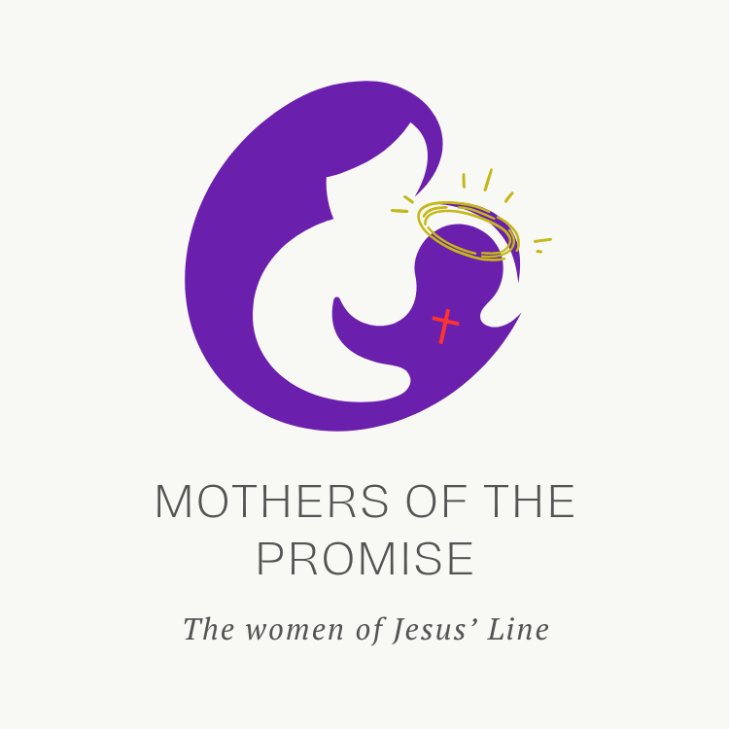

**CHRIST LUTHERAN CHURCH** | Vacaville, California

*September 14, 2025*

**WELCOME TO WORSHIP**

Welcome to Christ Lutheran Church. We pray that your soul will be strengthened by the good news about God’s grace, love, and forgiveness given to us. If you would like to learn more about our church, please speak with our pastor or one of our members after the service.

* **Bathrooms** are located in the fellowship hall. A changing table is located in the women’s bathroom.

**WORSHIP THEME**

Promises fulfilled. We have seen in the life of Tamar what happens when promises are broken. We have seen in the life of Rahab the way God keeps his promises through his people. In the life of Ruth, we see the fulfillment of every promise: a redeemer to renew and sustain us.

We are all children of the promise (Galatians 4:28). Through the promise of the gospel, we are all born again into the family of God. Every child has a mother. In three weeks, we will consider the lives and promises of three mothers in the line of Jesus, and what they can teach us about God’s grace, and the special mercy he extends to women.

***Matins***

*Matins was the service that marked the beginning of a new day for the monastic orders. Morning is a natural and necessary time for prayer, praise, and worship. As we begin not just a new day, but a new week, we glorify God and ask for his blessing.*

**HYMN** *For All the Faithful Women***|CW 893**

*The congregation will also sing v. 7, which recounts the life of Ruth.*

M: In the name of the Father, and of the Son, and of the Holy Spirit.

**C: Amen.**

M: O Lord, open my lips

**C: And my mouth shall declare your praise.**

M: Hasten to save me, O God.

**C: O Lord, come quickly to help me.**

**CONFESSION**

M: Beloved in the Lord: let us draw near with a true heart and confess our sins to God our Father, asking him in the name of our Lord Jesus Christ to grant us forgiveness.

**C: Holy and merciful Father, I confess that I am by nature sinful, and that I have disobeyed you in my thoughts, words, and actions. I have done what is evil and failed to do what is good. For this I deserve your punishment both now and in eternity. But I am truly sorry for my sins, and trusting in my Savior Jesus Christ, I pray: Lord, have mercy on me, a sinner.**

# absolution

M: God, our heavenly Father, has been merciful to us and has given his only Son to be the atoning sacrifice for our sins. Therefore, as a called servant of Christ and by his authority, I forgive you all your sins in the name of the Father and of the Son ✙ and of the Holy Spirit.

**C**: **Amen**

**PRAYER OF THE DAY**

M: The Lord be with you.

**C: And also with you.**

M: Let us pray.

O God, you have told us not to be anxious about what we need for this life. Move our hearts to seek you and your kingdom, that all good things may be given to us as well; through your Son, Jesus Christ our Lord, who lives and reigns with you and the Holy Spirit, one God, now and forever.

**C: Amen**

M: The Spirit of the Lord fills the world. Let us worship him.

**O COME LET US SING TO THE LORD**

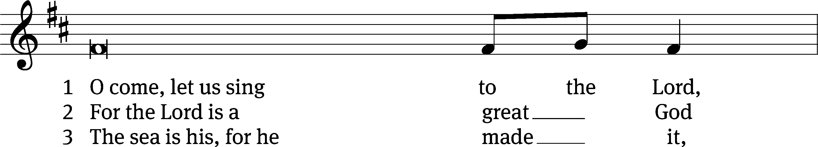

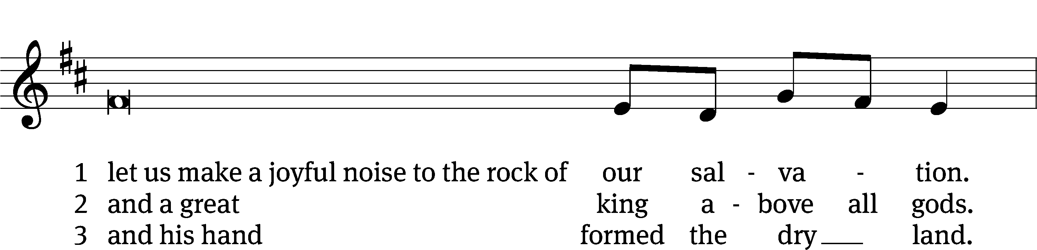

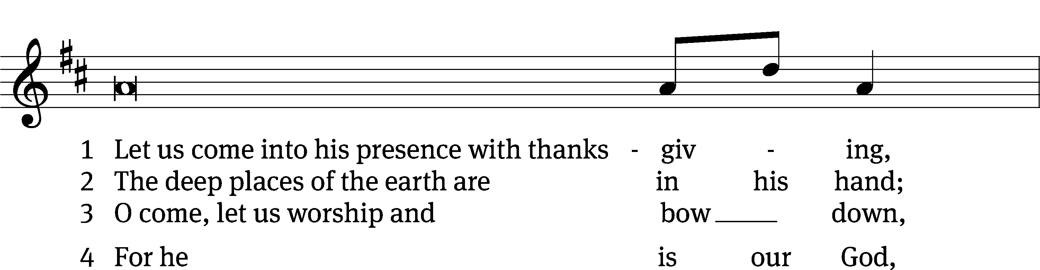

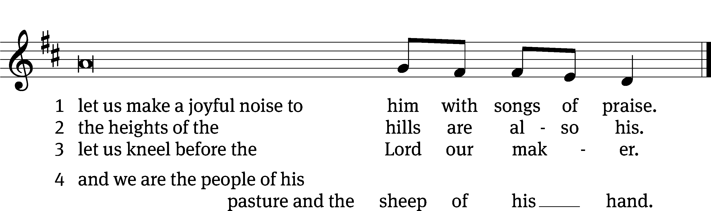

**FIRST LESSON** *Ruth 4:9–22*

*The history of Ruth is a fulfillment of God’s promises.*

Then Boaz announced to the elders and all the people, “Today you are witnesses that I have bought from Naomi all the property of Elimelek, Kilion and Mahlon. I have also acquired Ruth the Moabite, Mahlon’s widow, as my wife, in order to maintain the name of the dead with his property, so that his name will not disappear from among his family or from his hometown. Today you are witnesses!”

Then the elders and all the people at the gate said, “We are witnesses. May the Lord make the woman who is coming into your home like Rachel and Leah, who together built up the family of Israel. May you have standing in Ephrathah and be famous in Bethlehem. Through the offspring the Lord gives you by this young woman, may your family be like that of Perez, whom Tamar bore to Judah.”

So Boaz took Ruth and she became his wife. When he made love to her, the Lord enabled her to conceive, and she gave birth to a son. The women said to Naomi: “Praise be to the Lord, who this day has not left you without a guardian-redeemer. May he become famous throughout Israel! He will renew your life and sustain you in your old age. For your daughter-in-law, who loves you and who is better to you than seven sons, has given him birth.”

Then Naomi took the child in her arms and cared for him. The women living there said, “Naomi has a son!” And they named him Obed. He was the father of Jesse, the father of David.

This, then, is the family line of Perez:

Perez was the father of Hezron,

Hezron the father of Ram,

Ram the father of Amminadab,

Amminadab the father of Nahshon,

Nahshon the father of Salmon,

Salmon the father of Boaz,

Boaz the father of Obed,

Obed the father of Jesse,

and Jesse the father of David.

**PSALM**  *Psalm 127*

**SECOND LESSON** *1 Timothy 2:8–15*

*Women are essential to God’s plan of salvation.*

Therefore I want the men everywhere to pray, lifting up holy hands without anger or disputing. I also want the women to dress modestly, with decency and propriety, adorning themselves, not with elaborate hairstyles or gold or pearls or expensive clothes, but with good deeds, appropriate for women who profess to worship God.

A woman should learn in quietness and full submission. I do not permit a woman to teach or to assume authority over a man; she must be quiet. For Adam was formed first, then Eve. And Adam was not the one deceived; it was the woman who was deceived and became a sinner. But women will be saved through childbearing—if they continue in faith, love and holiness with propriety.

**VERSE OF THE DAY** *Matthew 6:33*

**Alleluia. Seek first his kingdom and his righteousness, and all these things will be given to you as well. Alleluia.**

**THE GOSPEL** *Luke 1:5–14*

*The birth of John the Baptist foretold.*

In the time of Herod king of Judea there was a priest named Zechariah, who belonged to the priestly division of Abijah; his wife Elizabeth was also a descendant of Aaron. Both of them were righteous in the sight of God, observing all the Lord’s commands and decrees blamelessly. But they were childless because Elizabeth was not able to conceive, and they were both very old.

Once when Zechariah’s division was on duty and he was serving as priest before God, he was chosen by lot, according to the custom of the priesthood, to go into the temple of the Lord and burn incense. And when the time for the burning of incense came, all the assembled worshipers were praying outside.

Then an angel of the Lord appeared to him, standing at the right side of the altar of incense. When Zechariah saw him, he was startled and was gripped with fear. But the angel said to him: “Do not be afraid, Zechariah; your prayer has been heard. Your wife Elizabeth will bear you a son, and you are to call him John. He will be a joy and delight to you, and many will rejoice because of his birth.”

M The Gospel of the Lord.

**C: Praise be to you, O Christ!**

**HYMN OF THE DAY** *The King of Love My Shepherd Is***| CW 552**

**SERMON** *Ruth 4*

**WE PRAISE YOU, O GOD**

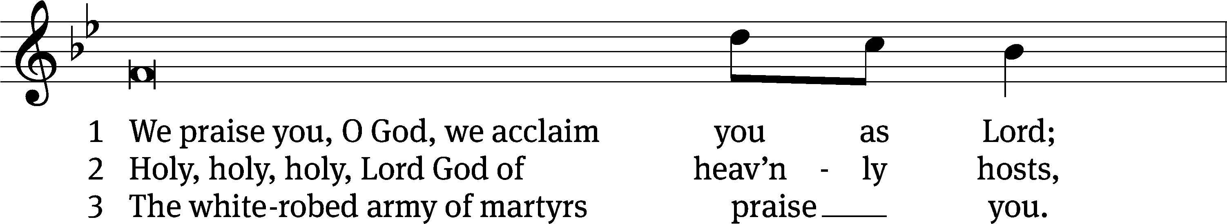

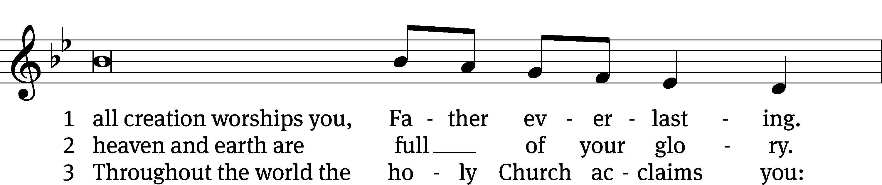

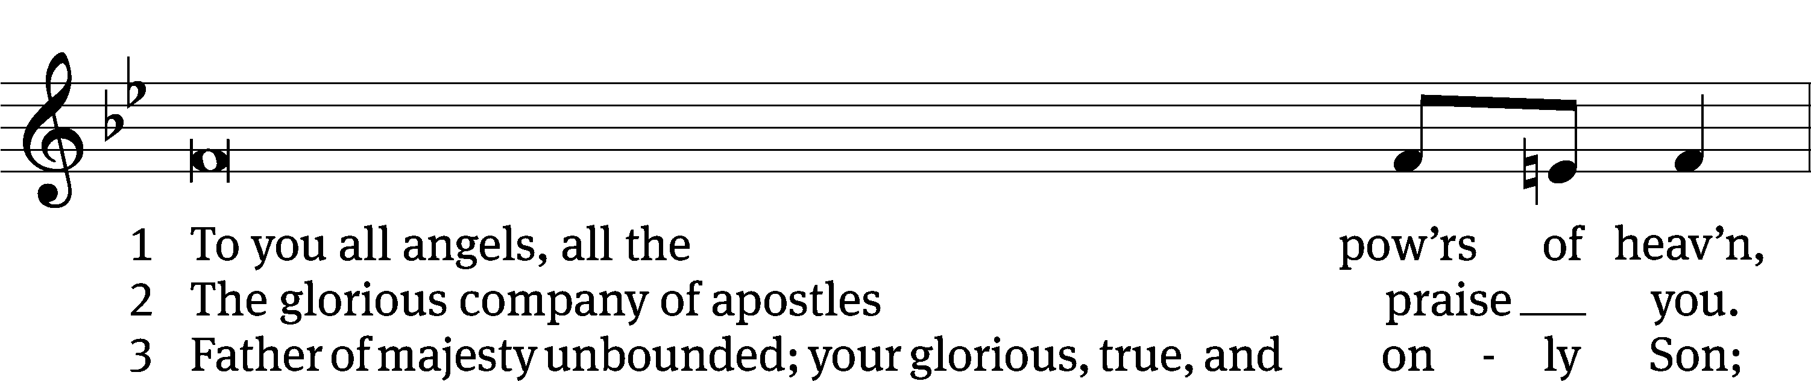

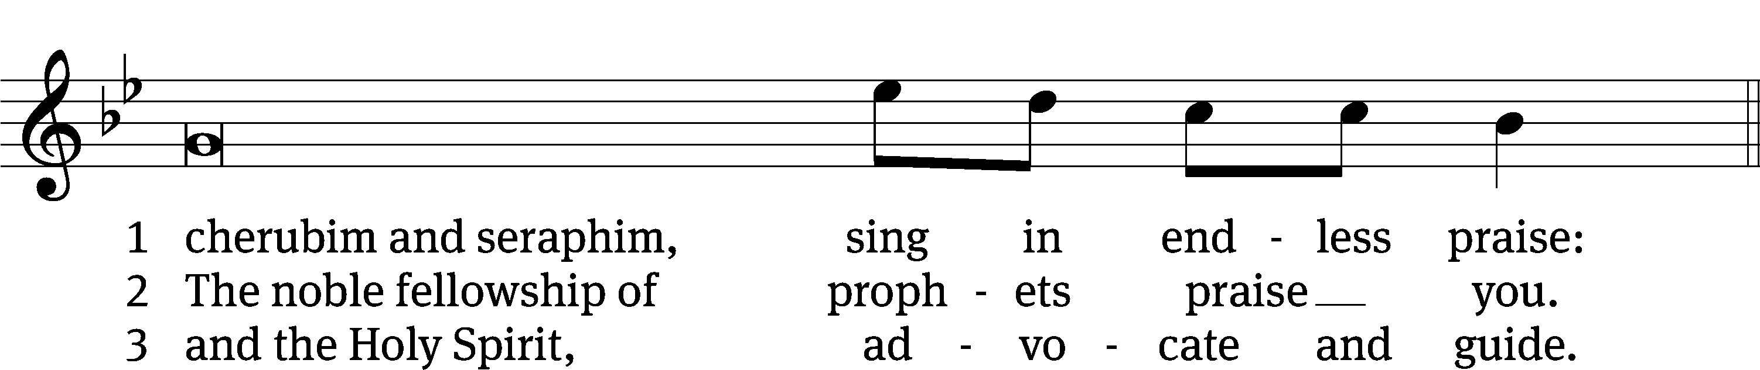

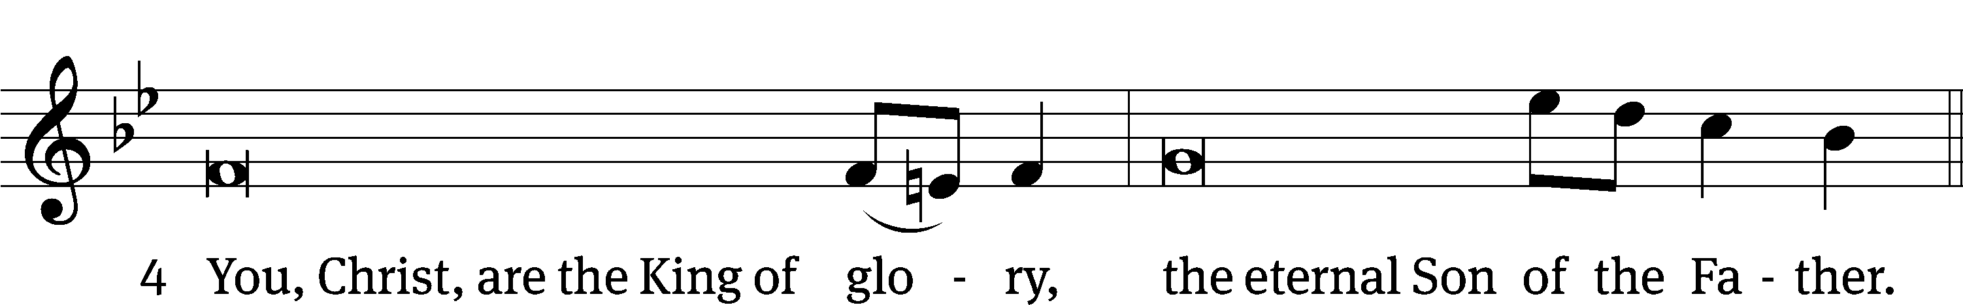

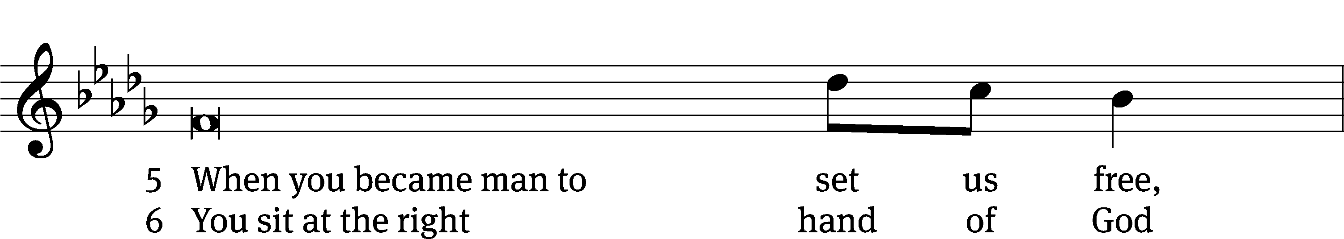

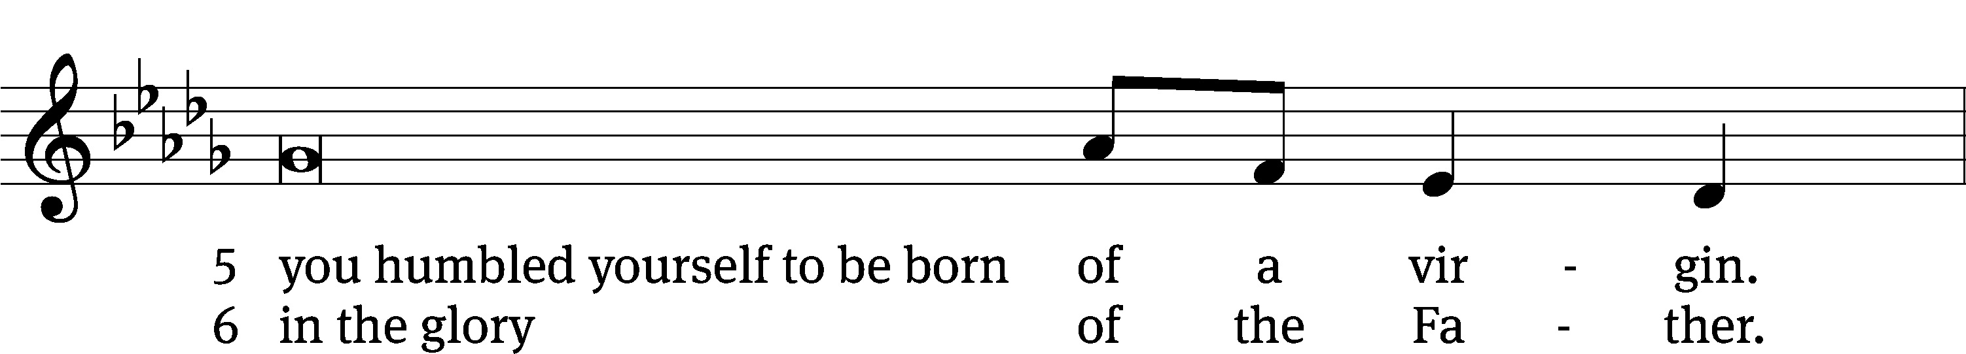

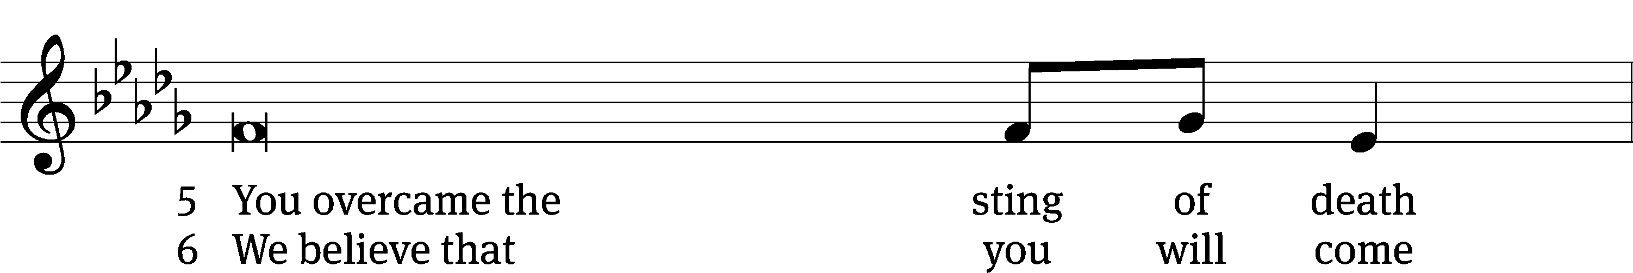

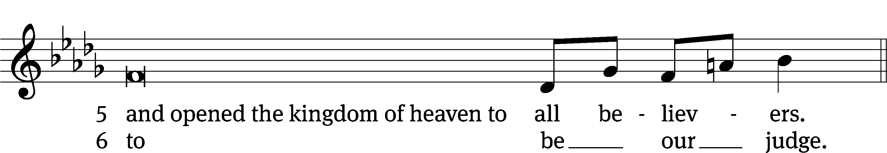



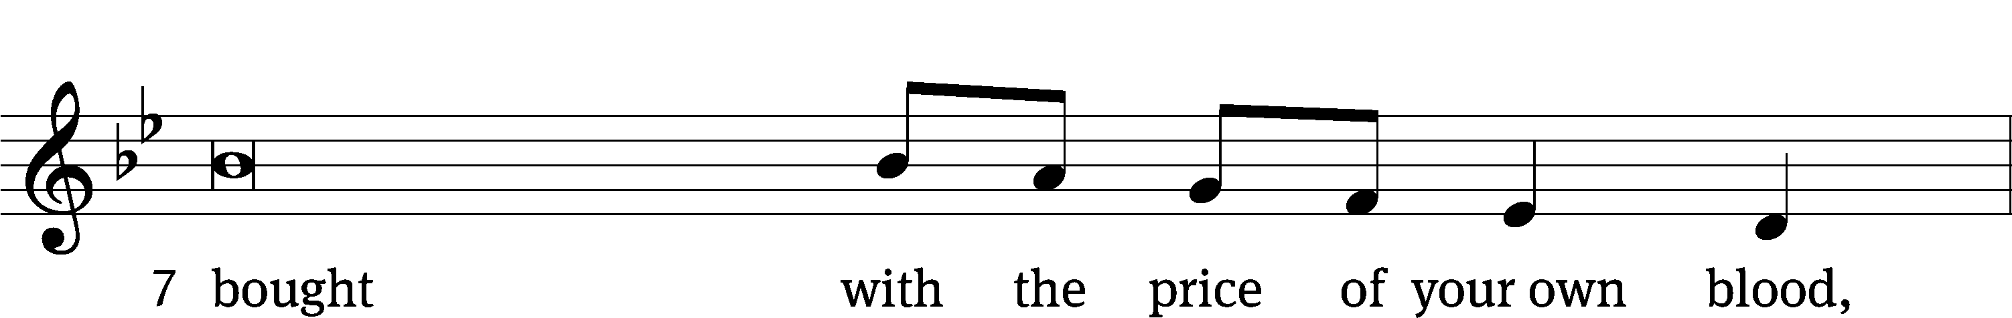

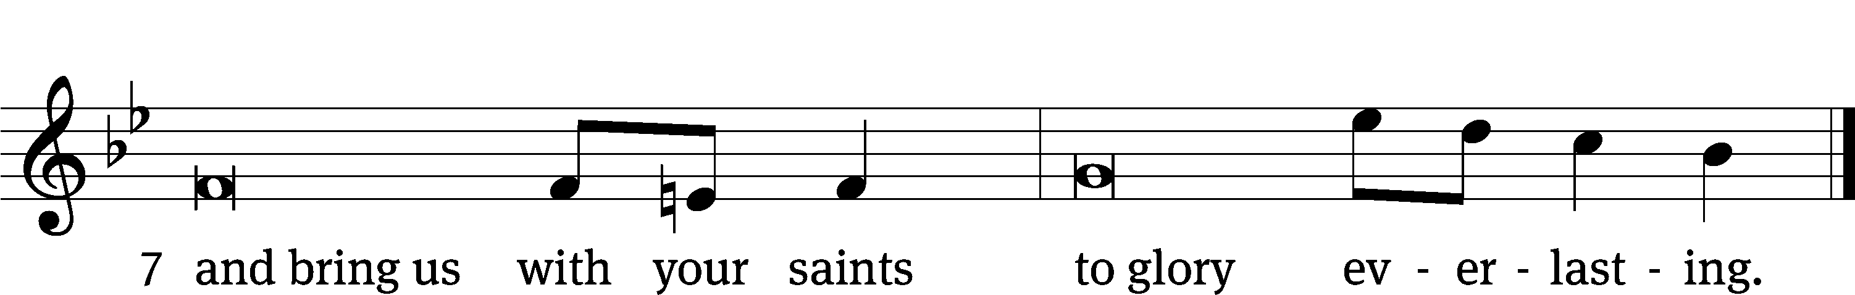

**OFFERING**

*In response to God’s love and forgiveness, we give back a portion of what he has given us. The members of Christ Lutheran Church have joined to proclaim the gospel to this community. These offerings support that work. While our guests are welcome to participate, they should not feel obligated to do so.*

**PRAYER OF THE CHURCH**

M: Kind Father, You invite us to pray in every circumstance and for all people without anger or dispute. In your eternal kindness, hear the prayers that we offer to you now on behalf of your Church, our people, and the world. Lord, in Your mercy,

**C: Hear our prayer.**

M: Almighty God, guide Your Holy Church here and everywhere, that those who have been called to serve as her pastors and church workers and those preparing for and considering full-time church work may be guarded against the assaults of the evil one, encouraged in their callings, and prepared to serve faithfully for the sake of the kingdom. Bless your servant Benjamin, who will be installed today at Living Word Lutheran Church in Petaluma. Lord, in Your mercy,

**C: Hear our prayer.**

M: Maker of heaven and earth, You have created man and woman for different offices and with different gifts, that they might complement one another and glorify You. Grant that, in our homes and congregations, Your people might rejoice in the callings You have given them. Move husbands to take seriously your call to love their wives as your Son has loved his Church. For wives who labor under husbands who mistreat, abuse, or neglect them, grant endurance and deliverance. Lord, in Your mercy,

**C: Hear our prayer.**

M: God, our Savior, uphold Donald, our president; Gavin, our governor; and all whom You have placed in high positions with wisdom and mercy, that we may lead peaceable and quiet lives, godly and dignified in every way. In a time of rising tension and heated division, shatter the arm of the wicked and bring their plans to nothing, and grant unity, kindness, and love among our people. Lord, in Your mercy,

**C: Hear our prayer.**

M: Heavenly Father, be with the sick and those who suffer, those troubled in mind, those grieving in their sorrows, and the dying in their last hours [especially _____________]. Grant them the comfort of Your presence, relief according to Your will and peace in their hearts. Lord, in Your mercy,

**C: Hear our prayer.**

M: Almighty God, You provide us with daily bread and with everything we need for this body and life. Free us from greed and covetousness, that we might be content with Your blessing and glad to share with those in need. Open out eyes to the needs of others, and remove our blindness to the ills around us. Lord, in Your mercy,

**C: Hear our prayer.**

M: O Lord, our God, whose mercies are new every morning, we give You thanks and praise for all Your kindness toward us, and we pray You to grant us the will and desire to worship You joyfully, to serve You faithfully and to proclaim boldly Your mighty acts of deliverance through our Lord, Jesus Christ, through whom we offer to You these prayers, and in whom we trust for all things; to You alone be glory, honor, worship and praise, O Lord, Father, Son and Holy Spirit, one God, now and forever.

**C: Amen.**

**LORD’S PRAYER** *Matthew 6:9-13; Luke 11:2-4*

**C: Our Father who art in heaven,**

**hallowed be thy name,**

**thy kingdom come,**

**thy will be done on earth as it is in heaven.**

**Give us this day our daily bread;**

**and forgive us our trespasses,**

**as we forgive those**

**who trespass against us;**

**and lead us not into temptation,**

**but deliver us from evil.**

**For thine is the kingdom, and the power,**

**and the glory**

**forever and ever. Amen.**

**THE BLESSING**

M**:** The Lord bless you and keep you.

The Lord make his face shine on you and be gracious to you.

The Lord look on you with favor and ✙ give you peace.

**C: Amen.**

**CLOSING HYMN** *God’s Own Child, I Gladly Say It***| CW 679**

**COPYRIGHT INFORMATION**

*Content requiring a copyright license is reproduced under OneLicense.net #A-718312. All rights reserved. The Common Service: Texts revised from The Lutheran Hymnal, 1941. Music revised by James Engel. Scripture Quotations: From the Holy Bible, New International Version (NIV 1984), © 1973, 1978, 1984 by Biblica, Inc.*



**13009 N. Elderberry Ct.**

**Lodi, CA 95242**

[www.christlodi.org](http://www.christlodi.org)

209-368-6250

Pastor Tim Leistekow

**WELCOME TO CHRIST EV. LUTHERAN CHURCH!**

We preach a message of forgiveness, hope and peace

through the death and resurrection of Jesus Christ.

Families and individuals of all ages will find opportunities

both to grow and to serve.

Our mission statement:

**Look what Christ is doing!**

He binds us together in fellowship

He gathers us in for worship

He builds us up for service

He sends us out with the gospel

*“Now you are the body of Christ,*

*and each one of you is a part of it.”*

*(1 Corinthians 12:27)*